 



Database Programming with SQL 16-1: Working with Sequences Practice Activities

# Objectives

* List at least three useful characteristics of a sequence
* Write and execute a SQL statement that creates a sequence
* Query the data dictionary using USER_SEQUENCES to confirm a sequence definition
* Apply the rules for using NEXTVAL to generate sequential numbers for use in a table
* List the advantages of caching sequence values
* Name three reasons why gaps can occur in a sequence

# Vocabulary

Identify the vocabulary word for each definition below.

|  |  |
| --- | --- |
| **CREATE SEQUENCE** | Command that automatically generates sequential numbers |
| **Sequences** | Generates a numeric value |
| **NEXTVAL** | Returns the next available sequence value |
| **INCREMENT BY** | Specifies the interval between sequence numbers |
| **NOMAXVALUE** | Specifies a maximum value of 10^27 for an ascending sequence and -1 for a descending sequence (default) |
| **CURRVAL** | returns the current sequence value |
| **MINVALUE** | specifies the minimum sequence value |
| **CYCLE/NOCYCLE** | specifies whether the sequence continues to generate values after reaching its maximum or minimum values |
| **NOMINVALUE** | specifies a minimum value of 1 for an ascending sequence and – (10^26) for a descending sequence (default) |
| **MAXVALUE/NOMAXVALUE** | specifies a maximum or default value the sequence can generate |
| **START WITH** | specifies the first sequence number to be generated |
| **CACHE/NOCACHE** | specifies how many values the Server pre-allocates and keeps in memory |

# Try It / Solve It

1. Using CREATE TABLE AS subquery syntax, create a seq_d_songs table of all the columns in the DJs on Demand database table d_songs. Use the SELECT * in the subquery to make sure that you have copied all of the columns.

CREATE TABLE seq_d_songs

AS ( SELECT * FROM d_songs);

DESCRIBE seq_d_songs;

DESCRIBE d_songs;

SELECT * FROM d_songs;

SELECT * FROM seq_d_songs;

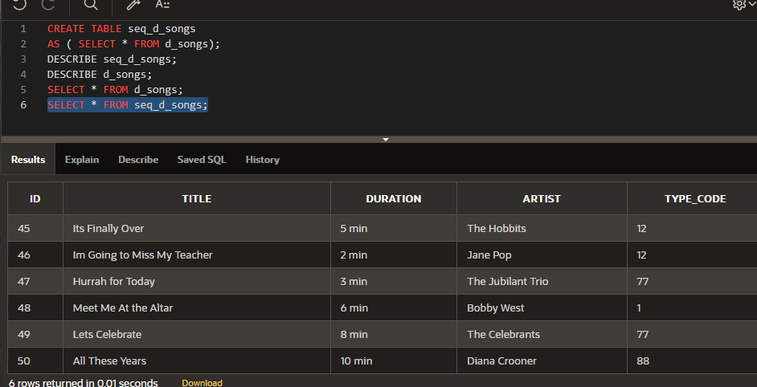

1. Because you are using copies of the original tables, the only constraints that were carried over were the NOT NULL constraints. Create a sequence to be used with the primary-key column of the seq_d_songs table. To avoid assigning primary-key numbers to these tables that already exist, the sequence should start at 100 and have a maximum value of 1000. Have your sequence increment by 2 and have NOCACHE and NOCYCLE. Name the sequence seq_d_songs_seq.

CREATE SEQUENCE seq_d_songs_seq

INCREMENT BY 2

START WITH 100

MAXVALUE 1000

NOCYCLE

NOCACHE;

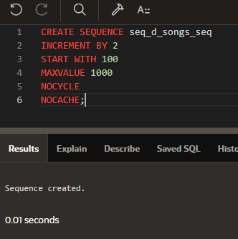

1. Query the USER_SEQUENCES data dictionary to verify the seq_d_songs_seq SEQUENCE settings.

SELECT * FROM user_sequences WHERE sequence_name = UPPER('seq_d_songs_seq');

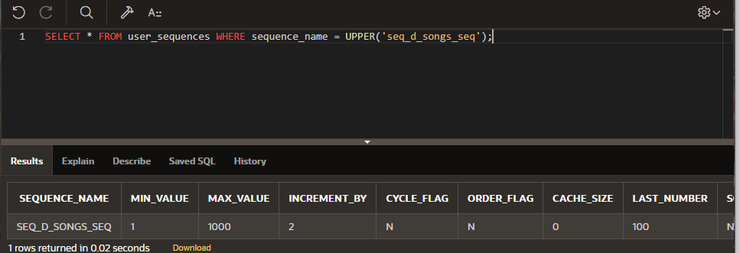

1. Insert two rows into the seq_d_songs table. Be sure to use the sequence that you created for the ID column. Add the two songs shown in the graphic.

|  |  |  |  |  |
| --- | --- | --- | --- | --- |
| ID | TITLE | DURATION | ARTIST | TYPE_CODE |
|  | Island Fever | 5 min | Hawaiian Islanders | 12 |
|  | Castle of Dreams | 4 min | The Wanderers | 77 |

INSERT INTO seq_d_songs (id,title,duration,artist,type_code)

VALUES(seq_d_songs_seq.NEXTVAL,'Surfing Summer',NULL,NULL,12);

INSERT INTO seq_d_songs (id,title,duration,artist,type_code)

VALUES(seq_d_songs_seq.NEXTVAL,'Victory Victory','5 min',NULL,12);

SELECT * FROM seq_d_songs ORDER BY id DESC;

SELECT * FROM user_sequences WHERE sequence_name = UPPER('seq_d_songs_seq');

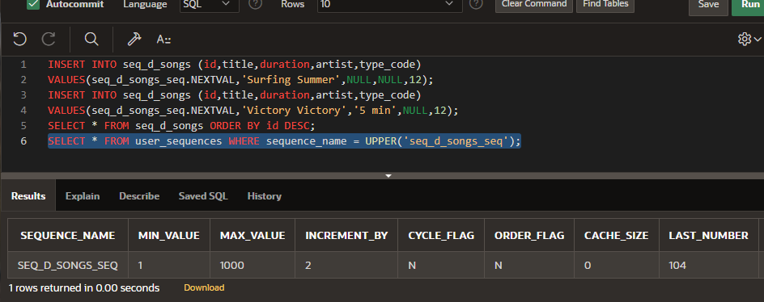

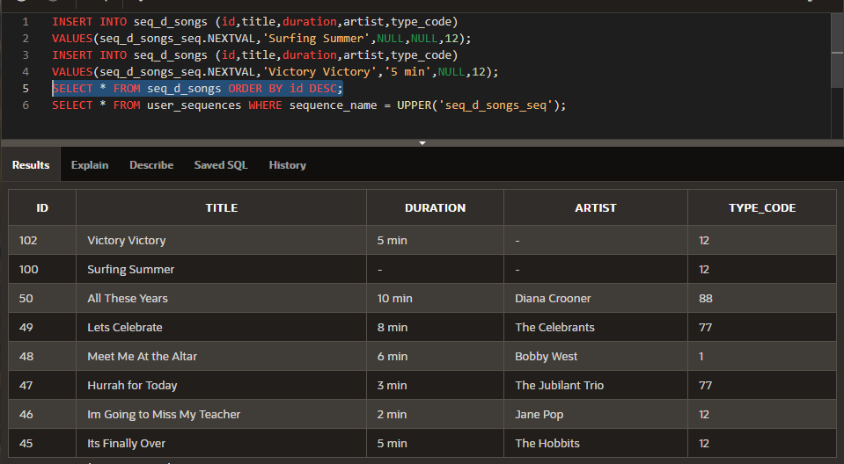

1. Write out the syntax for seq_d_songs_seq to view the current value for the sequence. Use the DUAL table. (Oracle Application Developer will not run this query.)

SELECT seq_d_songs_seq.CURRVAL FROM DUAL;

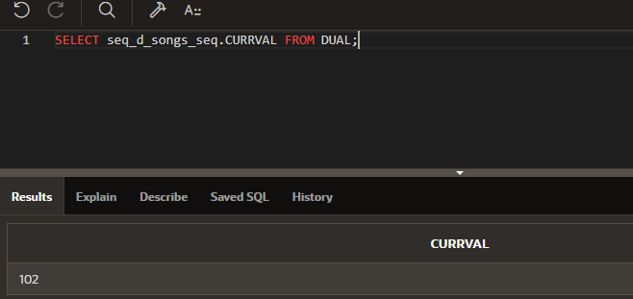

1. What are three benefits of using SEQUENCEs?

На их основе можно создавать ID

Удобство успользования, по сравнению с иными способами

Многократное использование

Доступно кэширование

1. What are the advantages of caching sequence values?

Производительность

1. Name three reasons why gaps may occur in a sequence?

Откат оператора, содержащего последовательность.

· Сбой системы, если система кэширует значения в памяти

· Одна и та же последовательность используется несколькими таблицами.

Extension Exercise

1. Create a table called “students”. You can decide which columns belong in that table and what datatypes these columns require. (The students may create a table with different columns; however, the important piece that must be there is the student_id column with a numeric datatype. This column length must allow the sequence to fit, e.g. a column length of 4 with a sequence that starts with 1 and goes to 10000000 will not work after student #9999 is entered.)

CREATE TABLE students1(

student_id NUMBER(6) CONSTRAINT sdt_sdt_id_pk PRIMARY KEY,

fname VARCHAR2(12),

lname VARCHAR(20),

sex CHAR(1),

major VARCHAR2(24)

);

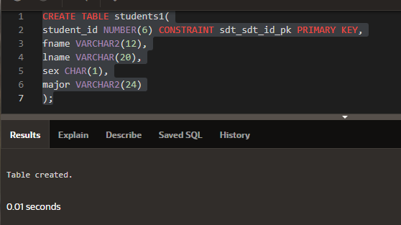

1. Create a sequence called student_id_seq so that you can assign unique student_id numbers for all students that you add to your table.

CREATE SEQUENCE student_id_seq

INCREMENT BY 1

START WITH 1

MAXVALUE 999999

NOCYCLE

NOCACHE;

SELECT * FROM user_sequences WHERE sequence_name = UPPER('student_id_seq');

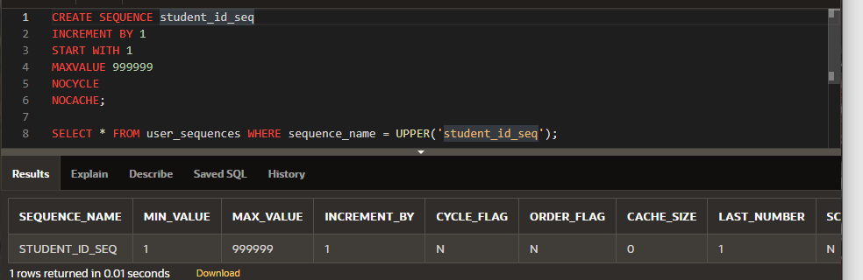

1. Now write the code to add students to your STUDENTS table, using your sequence “database object.”

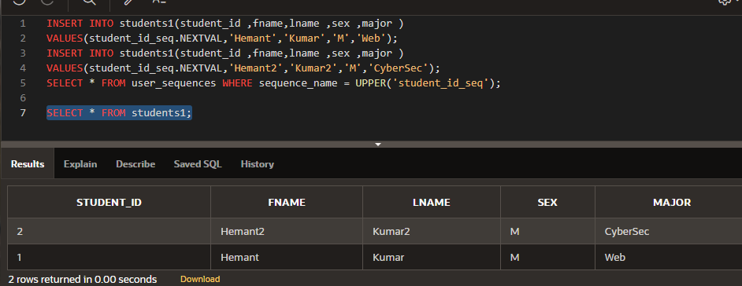

INSERT INTO students1(student_id ,fname,lname ,sex ,major )

VALUES(student_id_seq.NEXTVAL,'Hemant','Kumar','M','Web');

INSERT INTO students1(student_id ,fname,lname ,sex ,major )

VALUES(student_id_seq.NEXTVAL,'Hemant2','Kumar2','M','CyberSec');

SELECT * FROM user_sequences WHERE sequence_name = UPPER('student_id_seq');

SELECT * FROM students1;